**Daemonsets in Kubernetes**

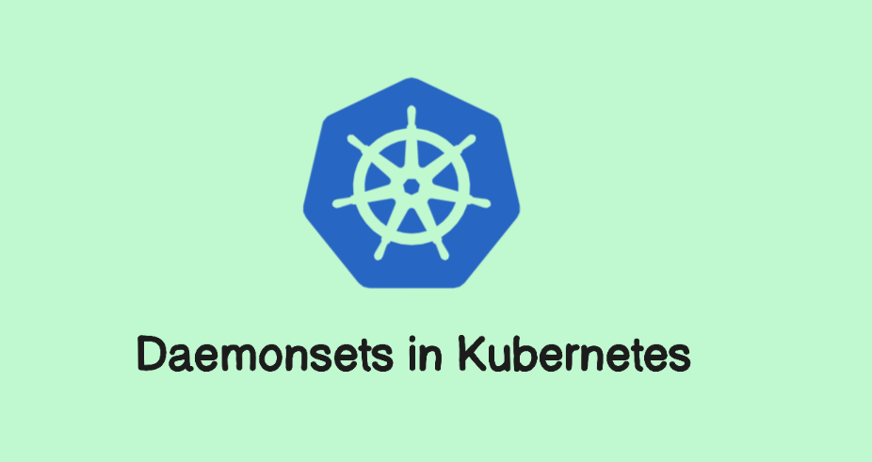

**Introduction**

A Kubernetes DaemonSet is a resource that ensures a specific pod runs on every node in a Kubernetes cluster or on a subset of nodes that meet specific criteria. It is used for deploying background services or agents that need to be present on all nodes, such as monitoring agents or log collectors. By automating the distribution of pods across nodes, DaemonSets help in maintaining consistent deployment and execution of node-specific tasks.

**What is Daemonsets ?**

A Kubernetes DaemonSet ensures that a specific pod runs on all (or a subset of) nodes in a Kubernetes cluster.

**Key Features:**

1. **Consistent Deployment**: Automatically deploys a pod to every node or to nodes that match specified criteria.
2. **Node-Specific Tasks**: Ideal for tasks that need to run on every node, such as log collection or monitoring agents.
3. **Automatic Updates**: Handles updates to pods across all nodes seamlessly.
4. **Consistent State**: Maintains a consistent state across the cluster, deploying or removing pods as nodes are added or removed.

**Use Case Example:** For a logging agent that needs to run on every node to collect and forward logs, you would use a DaemonSet. It ensures that each node in the cluster runs the logging pod, providing consistent log collection across the entire cluster.

A Simple diagram that explains daemon set working

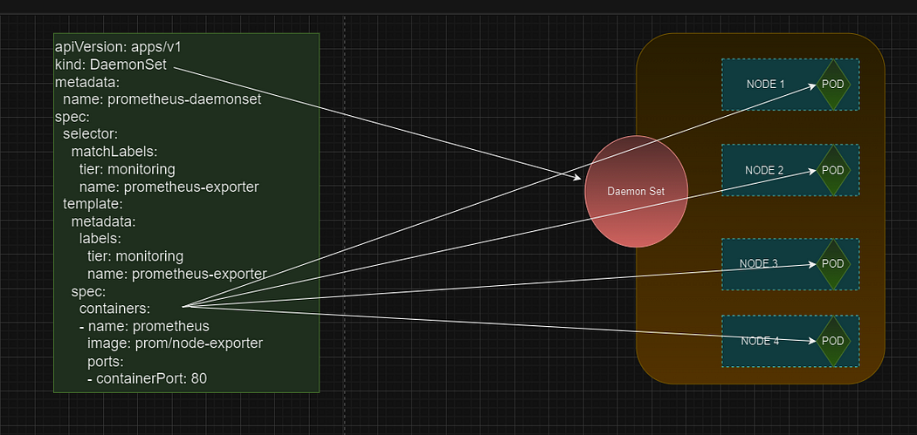

apiVersion: apps/v1  
kind: DaemonSet  
metadata:  
 name: prometheus-daemonset  
spec:  
 selector:  
 matchLabels:  
 tier: monitoring  
 name: prometheus-exporter  
 template:  
 metadata:  
 labels:  
 tier: monitoring  
 name: prometheus-exporter  
 spec:  
 containers:  
 - name: prometheus  
 image: prom/node-exporter  
 ports:  
 - containerPort: 9100

the above manifest file is for prometheus monitoring tool. The properties of daemon set are.,

**Kind:-** as we all know kind represents the kind of object we are defining. Here in our case it is DaemonSet

**Metadata:-** it contains the information related to DaemonSet. Here name and labels are related to DaemonSet.

**spec:-**This represents the specification of the DaemonSet.

**Template:-** basically template contains the pod specifications. As we know how to create a pod. In this template we need to keep an eye on giving the labels. Based on the label we define., selector will select the pods.

Commands to remember

To check the daemon set

kubectl get daemonset

To know the pods running on which node

kubectl get pods -A -o wide

In conclusion, a DaemonSet is essential in Kubernetes for deploying and managing pods that need to run on every node or a specific subset of nodes. It automates the process of ensuring consistent deployment and management of these pods, making it ideal for tasks like monitoring, logging, and network management that must be performed across all nodes in a cluster.